ARTIST-MENTORS for YOUTH ARTS
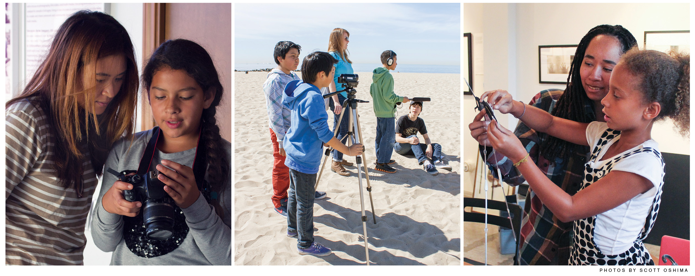

Photography Internship

Venice Arts’ mission is to ignite youths’ imagination, mentor their creativity, and expand their sense of possibility through high quality, accessible media-based arts education programs; and to serve as a catalyst for people of all ages, living in low-income or underrepresented communities, to create and share personal and community stories through photography, film, and multi-media.

Internship Description
The Filmmaking & Animation Education Intern will assist in Venice Arts’ filmmaking and animation programs for low–income youth. Her or his responsibilities will include any duties related to assisting in the programs; maintaining the digital labs; maintaining film equipment, preparing content to post online; archiving of student work, assisting with organization of film screenings, and potentially mentoring youth in our filmmaking and animation programs.

Qualifications
The ideal intern is a filmmaking major with experience working with youth. She or he is organized, motivated, and comfortable working in a community-based setting. Organizational and communication skills are of the utmost value in this position. Proficiency on Macintosh computers is required. Experience with the Adobe suite and Adobe Premiere is required.

Paid internship possible for students who are eligible for work-study. Otherwise, the internship is unpaid with possibility of academic credit (depending on your college's approval).

This is a part-time internship (3 hours per week based on availability).

How to Apply
A cover letter expressing your interest, along with your résumé, should be emailed to carly@venice-arts.org.

